1, OLTP vs. OLAP
Feature | OLTP | OLAP
Full form | Online Transaction Processing | Online Analytical Processing
Purpose | Handles daily transactions | Analyzes large amounts of data
Main focus | Insert, update, delete, and retrieve records | Complex queries, analysis, and reporting
Data | Current, detailed data | Historical and aggregated data
Users | Cashiers, customers, bank employees | Managers, analysts, business executives
Queries | Simple and frequent | Complex and often data-intensive
Speed | Very fast for individual transactions | Optimized for large analytical queries
Database design | Usually normalized | Often denormalized
Example | ATM withdrawal | Analyzing yearly bank transactions

1. OLTP (Online Transaction Processing)

OLTP systems handle everyday operations in real time.
Example: Banking system
When you withdraw 500 birr from an ATM, the system must:
  - Check your account balance.
  - Deduct 500 birr from your account.
  - Record the transaction.
  - Update your remaining balance.
The transaction must be fast and accurate.
Other examples: Online shopping, airline ticket booking, and supermarket checkout systems.

2. OLAP (Online Analytical Processing)
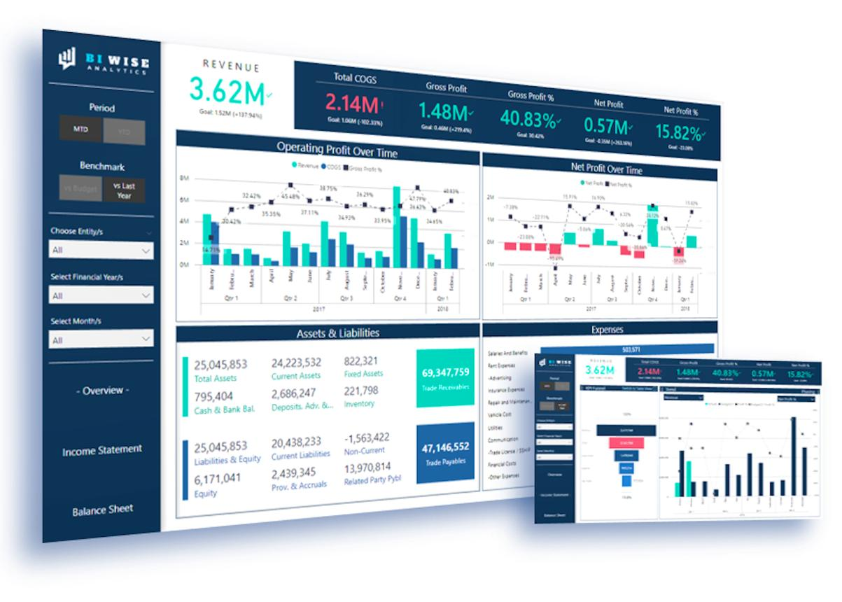
OLAP systems analyze data to help people understand trends and make decisions.
Example: Banking system
A bank manager wants to know:
  - How much money was withdrawn in the last year?
  - Which branches have the most transactions?
  - Which month had the highest number of withdrawals?
  - How has customer activity changed over five years?
OLAP analyzes large amounts of data to answer these questions.
Other examples: Sales reports, business intelligence dashboards, and financial forecasting.

3. Simple way to remember
OLTP = Do the work
Records a customer's purchase, updates an account, or books a ticket.
OLAP = Understand the data
Analyzes purchases, account activity, or ticket sales to identify trends.

4. How they work together
Imagine an online shopping company:
  - OLTP: A customer buys a phone, and the system records the order and updates inventory.
  - Data warehouse: Transaction data is collected and prepared for analysis.
  - OLAP: The company analyzes monthly sales to determine its best-selling phones.
In short: OLTP supports daily business operations; OLAP supports business analysis and decision-making.

2,OLTP vs. Data Warehousing
Feature | OLTP | Data Warehousing
Meaning | Online Transaction Processing | A system for storing integrated data for analysis
Purpose | Handle daily business transactions | Store data for reporting and analysis
Data | Mostly current, detailed data | Historical data from multiple sources
Operations | Insert, update, delete, retrieve | Load, store, query, analyze
Users | Cashiers, customers, operational staff | Managers, analysts, decision-makers
Design | Usually normalized | Often dimensional, using star or snowflake schemas
Example | Recording a bank deposit | Analyzing five years of bank deposits
- 1. OLTP
- 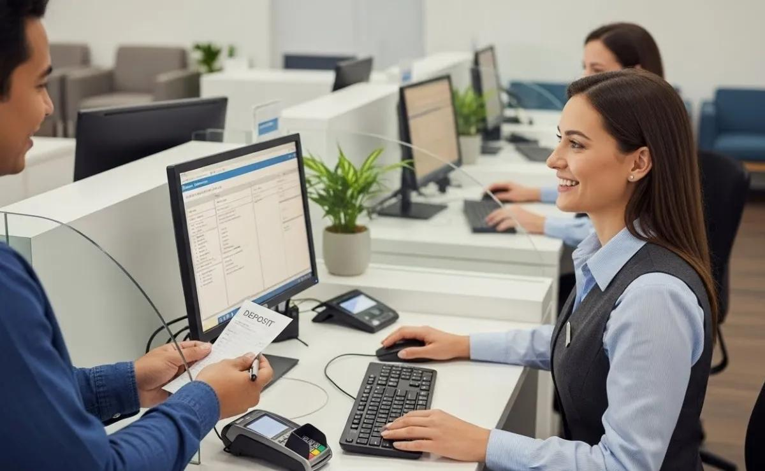
- OLTP is used to process everyday transactions quickly and accurately.
- Example: When you deposit 1,000 birr into your bank account, the OLTP system records the deposit and updates your balance.
- 2. Data Warehousing
- 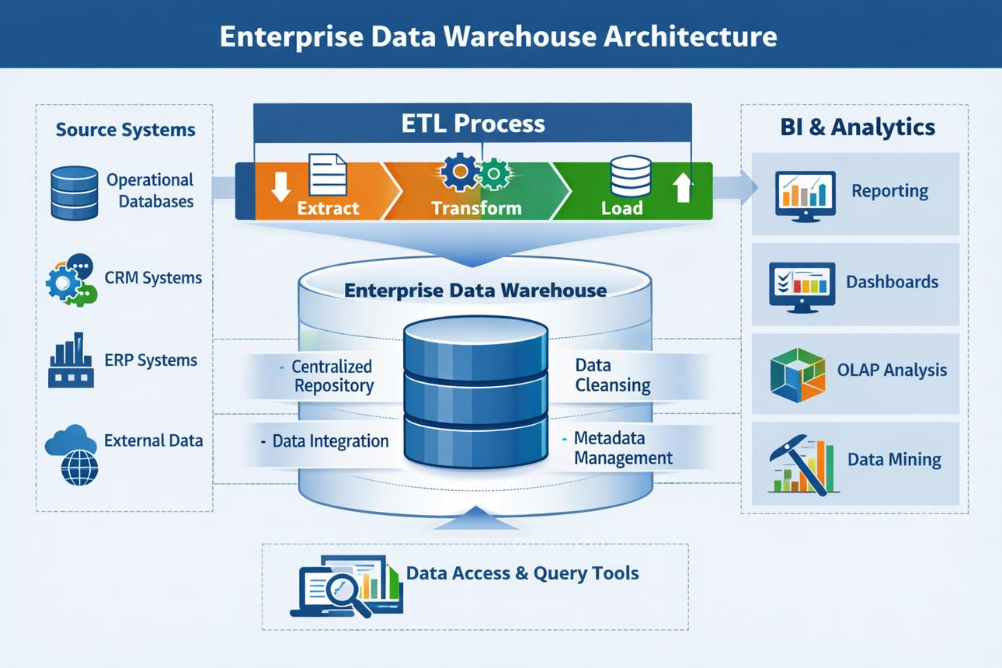
- A data warehouse collects and organizes data from different sources so it can be analyzed over time.
- Example: A bank uses its data warehouse to analyze deposits across all branches over the past five years.
- 3. How they work together
- OLTP systems
- Daily transactions: deposits, withdrawals, payments
- ETL / ELT process
- Extract or ingest, transform, and load data
- Data warehouse
- Stores integrated historical data
- OLAP and reporting
- Analyzes trends and produces reports
- 4. Remember the difference
  - OLTP = processes transactions.
  - Data warehouse = stores and organizes data for analysis.
  - OLAP = analyzes data using complex queries.
Exam tip: OLTP is an operational processing system, whereas a data warehouse is an analytical data repository. OLAP is the analytical processing approach often used to analyze data in a data warehouse.

